Module 3 Lab Assignment
Rezoan Hossain
CUNY School of Professional Studies
IS 383 Data Acquisition and Analysis

This lab assignment was completed in RStudio. The first case problem focused on data preparation, missing values, duplicate records, and filtering. The second case problem focused on binary variables and hierarchical clustering.

Chapter 4: Usman Solutions
I loaded the Knoxville and Boise text files into RStudio and checked that both files had the same columns. Then I added a Market field to both files and combined them into one data set called porter_hinkle.
After combining the data, I checked for missing values and duplicate records. I found 5 missing values and 2 duplicate records. Both duplicate records were in the Boise market.
Next, I created a new field called Taste by taking the average of Saltiness, Sweetness, and Flavor. After that, I created a filtered data set called young_no for respondents under age 35 who answered No to the Crispy Spuds question.
Table 1
Chapter 4 Data Preparation Summary
Item | Result
Combined file | 453 rows, 11 columns before Taste
Combined rows and columns | 453 rows, 11 columns
Missing values found | 5
Duplicate records found | 2
Duplicate respondents | Boise 123 and Boise 171
Filtered file | young_no.xlsx
Filtered rows and columns | 81 rows, 12 columns
Table 2
Missing Values by Field
Field | Missing Values
Respondent | 0
Age | 0
Regularly Consume Crispy Spuds? | 2
Crispiness | 0
Saltiness | 1
Sweetness | 1
Flavor | 0
Texture | 0
Value | 0
Overall | 1

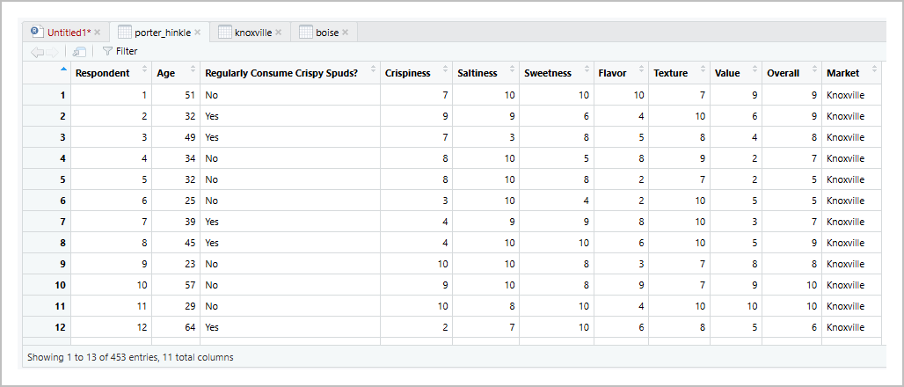
Figure 1. Combined porter_hinkle data set after adding the Market field.
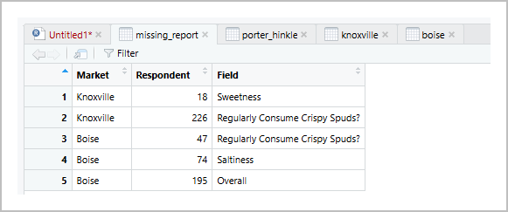
Figure 2. Missing value report showing the five records with missing values.

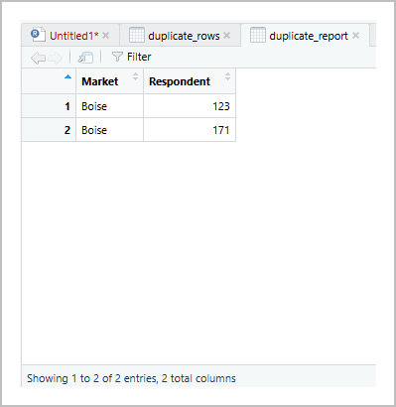
Figure 3. Duplicate report showing the duplicate Boise respondents.
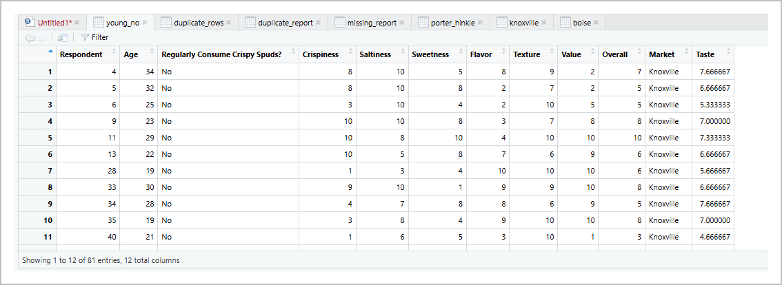
Figure 4. Filtered young_no data set for respondents under age 35 who answered No.

Chapter 6: Know Thy Customer
For the Know Thy Customer case, I loaded the ktc.csv file into RStudio and removed the blank extra columns. After cleaning, the file had 600 rows and 7 columns.
Then I created six binary variables for clustering: Retirement, MiddleUpper, Married, FamilyPlan, MastersPlus, and Own. These variables were based on the conditions from the case problem and were used for hierarchical clustering.
I applied hierarchical clustering with binary distance and average linkage. I checked several values of k using average silhouette and selected 2 clusters because k = 2 had the highest average silhouette value.
Table 3
Binary Variable Totals for the KTC Data Set
Binary Variable | Total Values
Retirement | 146
MiddleUpper | 143
Married | 396
FamilyPlan | 290
MastersPlus | 186
Own | 422

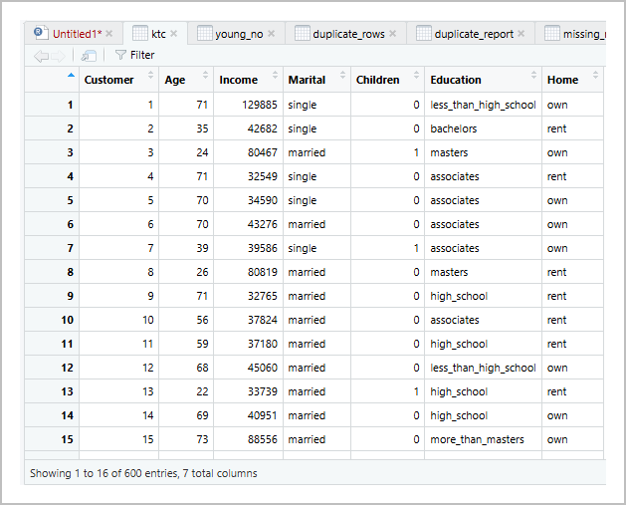
Figure 5. Cleaned KTC data set after removing blank extra columns.
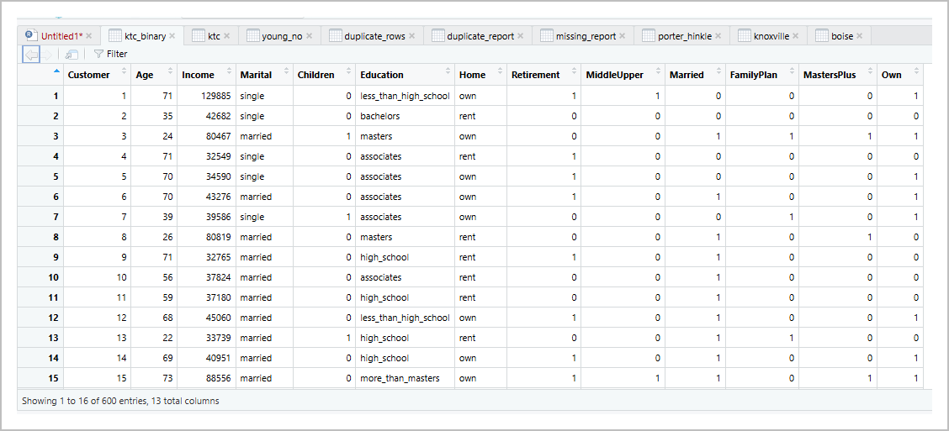
Figure 6. KTC data set after the six binary variables were created.

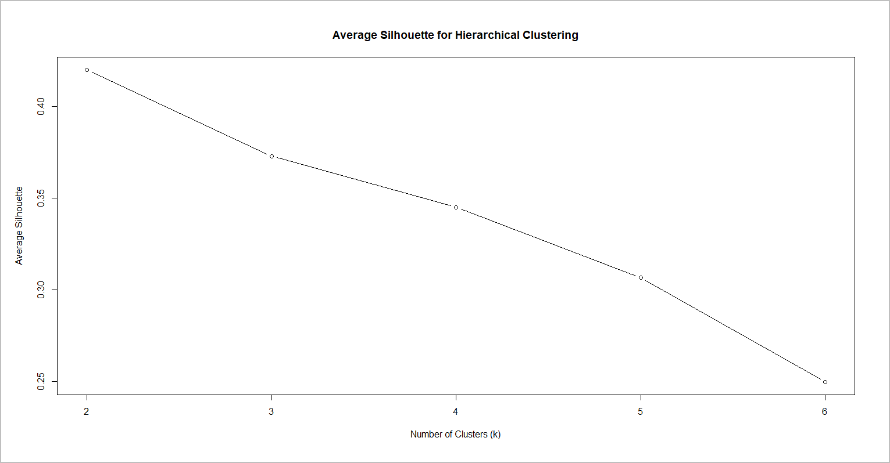
Figure 7. Average silhouette values used to compare different cluster choices.
Table 4
Average Silhouette Values by Number of Clusters
Number of Clusters | Average Silhouette
2 | 0.420
3 | 0.373
4 | 0.345
5 | 0.307
6 | 0.250

Table 5
Cluster Sizes and Profile Summary
Cluster | Customers | Retirement | MiddleUpper | Married | FamilyPlan | MastersPlus | Own
1 | 572 | 0.255 | 0.250 | 0.692 | 0.507 | 0.325 | 0.738
2 | 28 | 0.000 | 0.000 | 0.000 | 0.000 | 0.000 | 0.000
Cluster 1 was the main customer group with 572 customers. This group was more likely to be married, own a home, and have children. Some customers in this group were also in retirement age, had middle or upper income, or had a master’s degree or higher.
Cluster 2 had 28 customers. This smaller group scored 0 for all six binary variables. This means the customers in this group were generally not retired, not middle or upper income, not married, had no children, did not have a master’s degree or higher, and did not own a home.
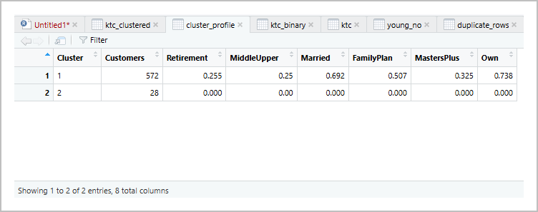
Figure 8. Cluster profile output for the final two-cluster solution.

Conclusion
In this lab, I cleaned and prepared the data, checked for missing values and duplicate records, created new variables, and used clustering to group customers. The Chapter 4 case showed data preparation and filtering, and the Chapter 6 case showed how clustering can organize customers into meaningful segments. Overall, the results helped organize the data into clear and useful groups.

References
Camm, J. D., Cochran, J. J., Fry, M. J., & Ohlmann, J. W. (2024). Business analytics (5th ed.). Cengage.

